Week 5 – Advanced Security and Monitoring Infrastructure
1. Mandatory Access Control Using AppArmor
Objective
Mandatory Access Control (MAC) was achieved through AppArmor, which limits the actions of programs even more than the traditional UNIX permissions do. AppArmor's profiles specify what resources the applications may use, and in this way, they lessen the damage caused by possible breaches.
By default, AppArmor is a part of the Ubuntu Server, thus it posits the right conditions for application-level security policies to be enforced.
Verifying AppArmor Status
Machine: Ubuntu Server (via SSH)
Sudo aa-status
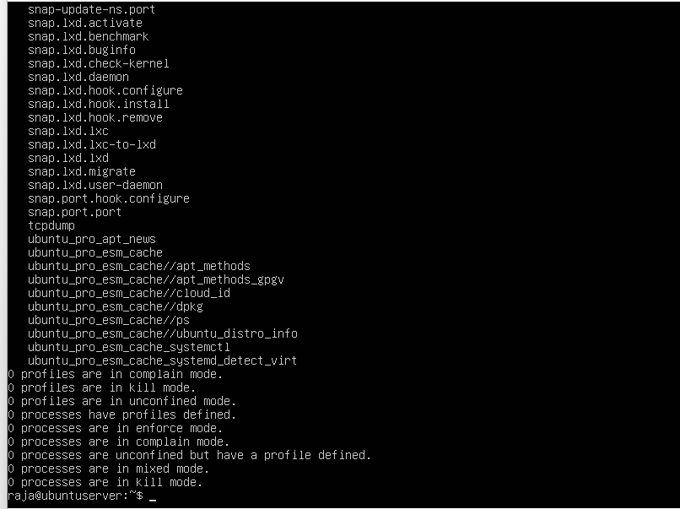

Enforcing AppArmor Profiles
To ensure profiles are actively enforced:
sudo aa-enforce /etc/apparmor.d/*
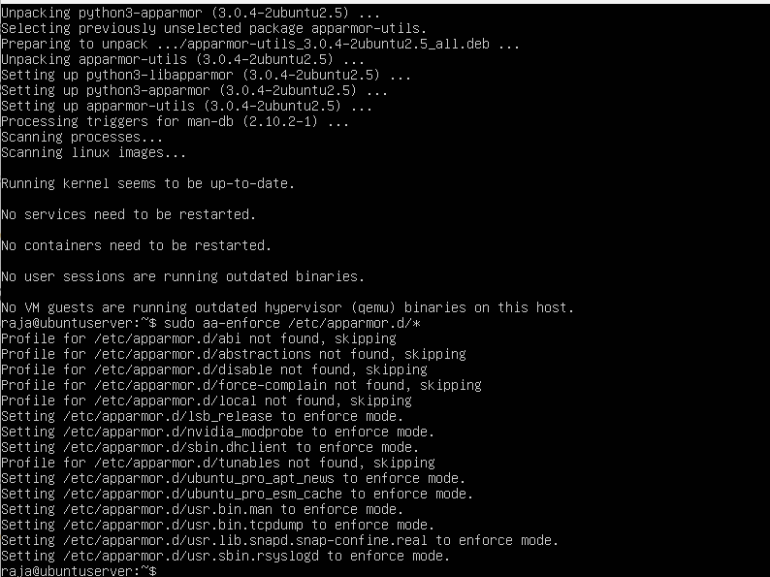

Tracking and Reporting AppArmor Activity
sudo journalctl -xe | grep apparmor
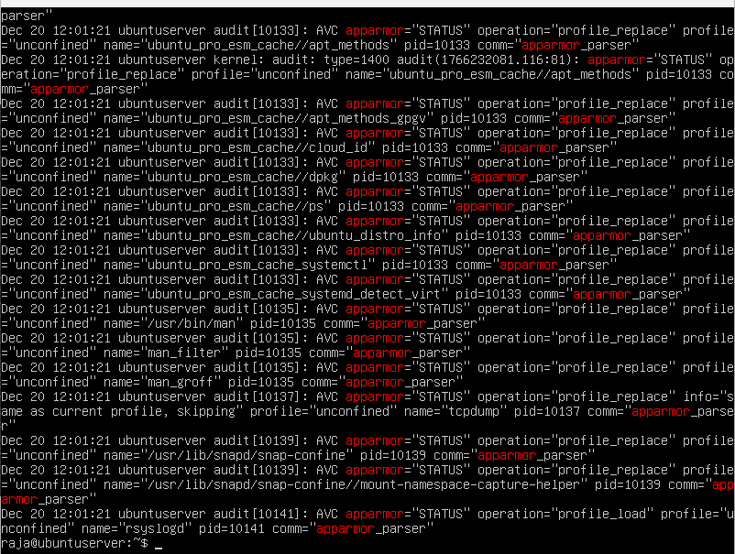
2. Automatic Security Updates Configuration
Objective
Automatic security updates are a great way to fix vulnerabilities in a timely manner without requiring any manual work. This not only reduces the risk of being attacked through known exploits but also keeps the system secure.
Installing Unattended Upgrades
Machine: Server (via SSH)
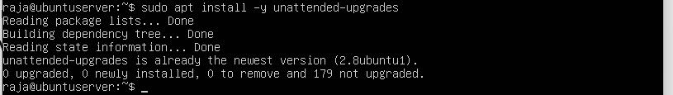
Enabling Automatic Security Updates
sudo dpkg-reconfigure --priority=low unattended-upgrades
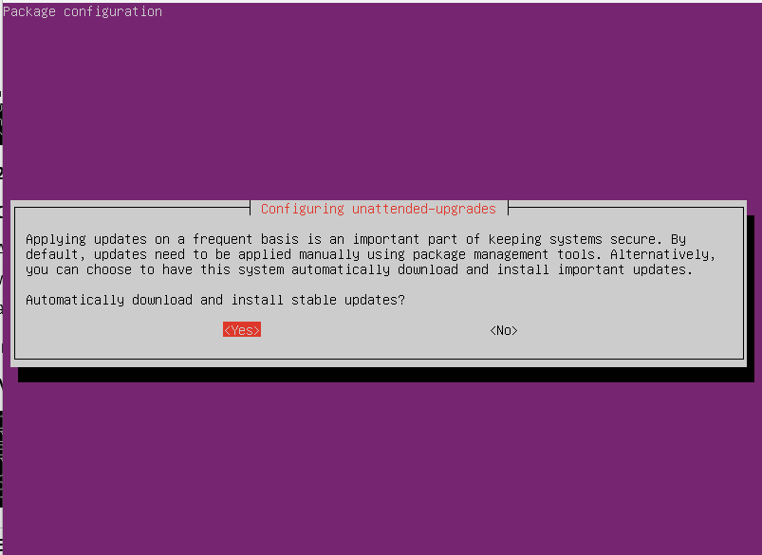
Verifying Configuration
cat /etc/apt/apt.conf.d/20auto-upgrades
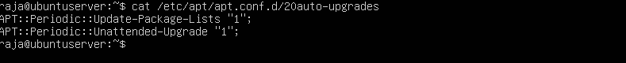
3. Intrusion Detection Using Fail2Ban
Objective
Fail2Ban is a security tool that monitors logs of authentication to protect the server from brute-force attacks and subsequently bans the IP addresses of the offenders on its own.
Installing Fail2Ban
Machine: Server (via SSH)
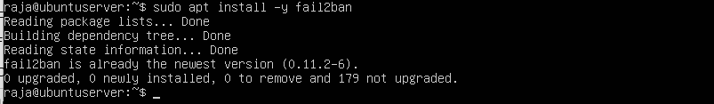
Configuring Fail2Ban for SSH Protection
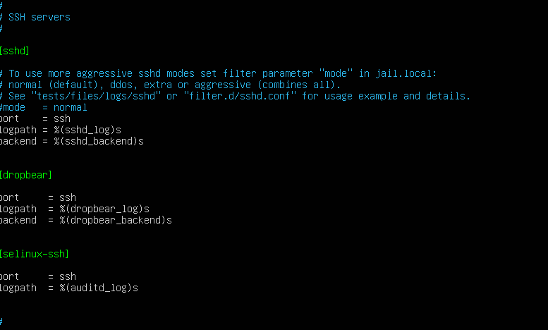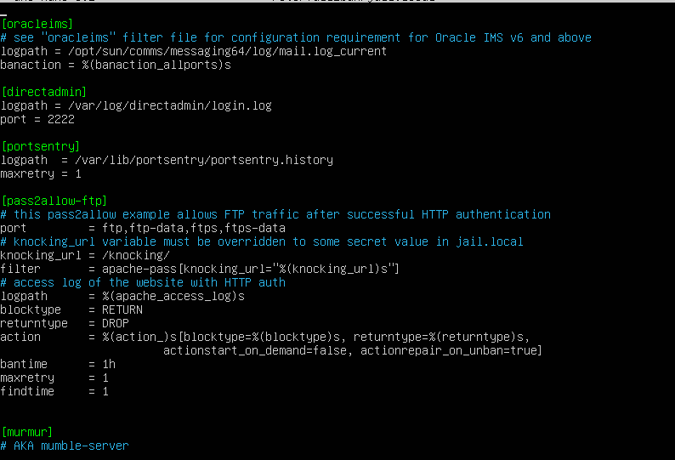
Restarting and Verifying Fail2Ban
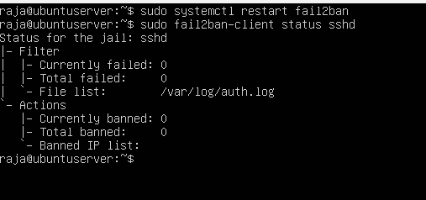
4. Security Baseline Verification Script (security-baseline.sh)
Objective
Creating a security baseline script for the purpose is to automatically ensure proper implementation for all security controls described during Weeks 4 and 5.
Script Creation
Machine: Server (via SSH)
nano security-baseline.sh
security-baseline.sh (Fully Commented)
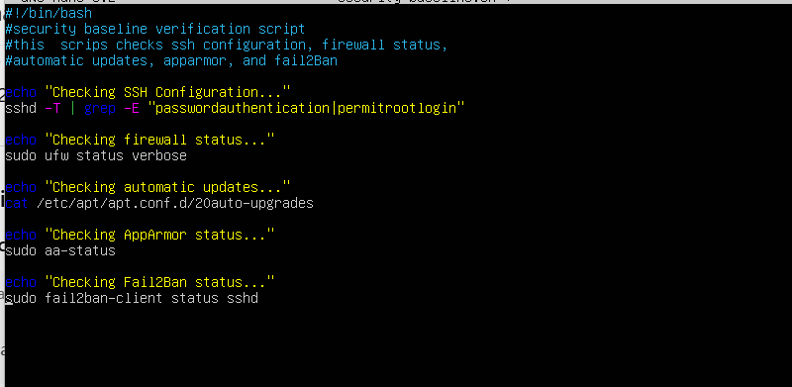
Making Script Executable and Running It
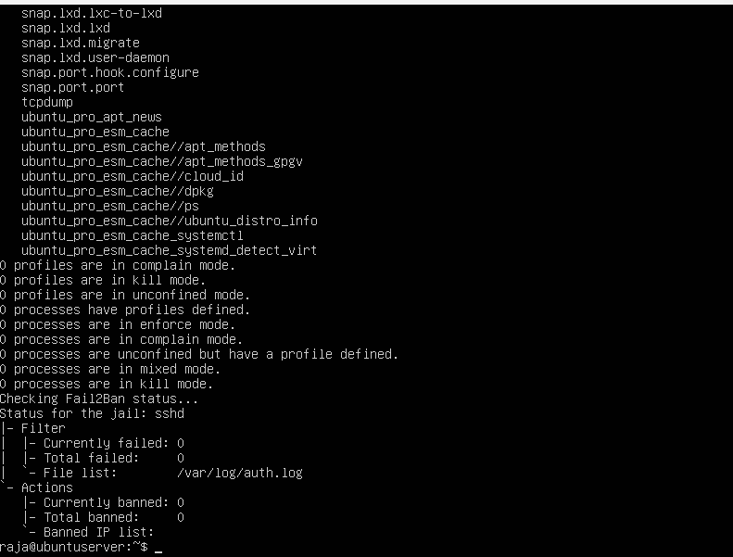
5. Remote Monitoring Script (monitor-server.sh)
Objective
We have written some scripts so that on the work station and via the SSH protocols, real-time performance metrics like system performance must be extracted from the server.
Script Creation
Machine: Ubuntu Desktop Workstation
nano monitor-server.sh
monitor-server.sh (Fully Commented)
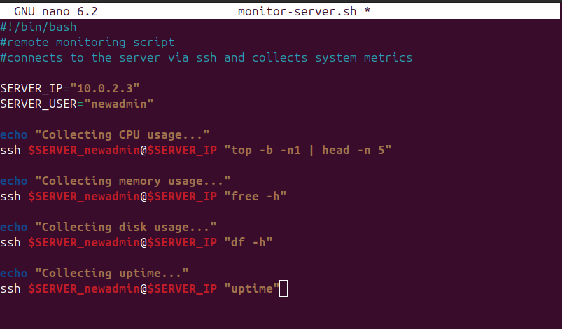

Running the Monitoring Script
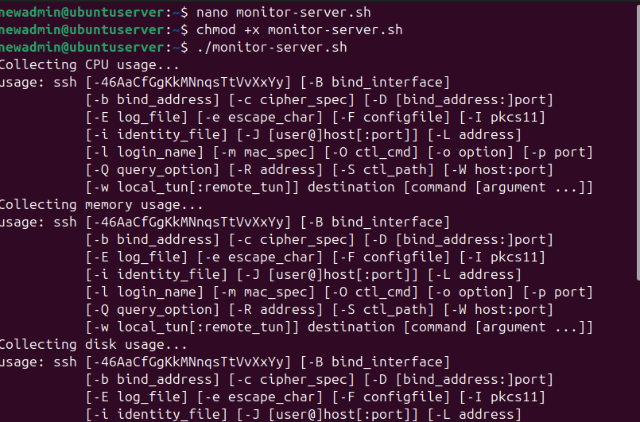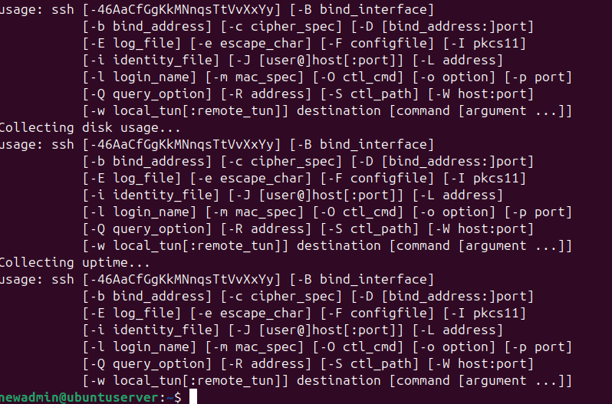
Conclusion
In the fifth week, the server's defense was significantly reinforced through the use of advanced security mechanisms. The cutting-edge security measures that were adopted included Mandatory access control through AppArmor, as well as automatic security updates that were implemented to limit exposure to vulnerabilities. Fail2Ban was also installed to prevent brute force attacks. In addition to these measures, a script was created for verifying the security baseline, which would conduct a systematic validation of all the security controls, while another script for remote monitoring would allow real-time performance data collection from the workstation. All these implementations have not only lifted system resilience, visibility, and manageability but also established a firm ground for the performance testing and security auditing of the next phases.

